EXERCISE NO:14
DATE:24/11/2020
AIM:
To Write a Python class to find validity of a string of parentheses.
PROGRAM:
class validity:
def f(str):
a=['()','{}','[]']
while any(i in str for i in a ):
for j in a:
str=str.replace(j,'')
return not str
s=input()
if(validity.f(s)):
print("valid")
else:
print("invalid")

LINK:
http://103.53.53.18/mod/vpl/forms/submissionview.php?id=327&userid=1692
OUTPUT:
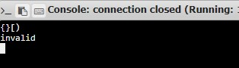

RESULT:
Hence , the Python class to find validity of a string of parentheses is printed.

